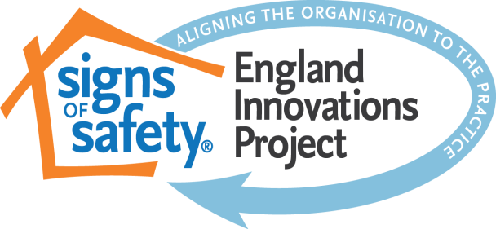
West Sussex Children’s Social Care
Signs of Safety Risk Assessment and Planning document
Name of child:  Name of worker undertaking this mapping:  Type of meeting/reason mapping completed:  e.g. 1st Core Group / family visits / SW Rep to ICPC  Chairs ICPC report / Group Supervision / used for analysis by social worker/CIN visit/CIN review  Is this an initial or review mapping?  Date of this mapping: | Date Genogram / Eco-map Completed:  Date Chronology last updated:  Date of last visit to child:  Date and type of direct work last undertaken with child: | Present at mapping meeting:  Absent from mapping meeting:

What are the child’s views on the help they are getting from children’s services? | What are the parents/carers/other family members views on the help they are getting from children’s services? | Practice manager comments:  Is the child involved in and aware of the plan to keep them safe?  Y/N  Are the parents/carers/family and kinship networks involved in the plan?  Y/N  Are all professionals involved in the plan?  Y/N  Have you checked the mapping, danger statements and safety goals for plain language (no jargon) and detail?  Y/N  Are the safety goals being met? If not, what needs to happen?

What are we worried about | What is working well | What needs to happen
What is the current evidence of Harm to the child?  - Evidence child has been harmed/impact (including evidence from history/chronology)  What are the complicating factors?  - Are there behaviours that pose a risk?  (parent/carer/child themselves/other person)  - Are there things happening in the child or family’s life that are making the situation harder?  If this is a review document, update the information and remove anything no longer relevant.  Ensure that plain and simple language is used – no jargon.  Ensure that the child’s views are recorded. | Safety  - Proven and tested safety which keeps child safe – provided by the family/child/kinship networks.  Strengths  - What are the strengths in this child/young person or their family/networks that might be built upon to work towards the safety goal? (make sure these are purposeful and relevant to the worries)  Has a child relevant version of the safety plan been completed? What are the child’s views? Does the child know how they will be kept safe/looked after well? | Next Steps  - What questions do you need to ask/what gaps do you have in your knowledge to establish if harm has occurred or if there is safety?  - Immediate steps people will take to make the child safe now (family and professionals)  - Referrals for services to help towards the safety goal?  - (Safety and service plan are at the end of this document and should be completed separately)  - What are the child’s goals?  - What are the parent/carers/kinship networks goals?  - Are there other people I need to include? Have I included family/friends networks?

DANGER STATEMENTS | SCALING – 0-10 | SAFETY GOALS
Analysis of who is worried, what are they worried about and why (possible future impact.  Complete a separate danger statement and corresponding safety goal for each worry. | Overall, where does everybody scale this child’s safety today, where 10 is safe enough for social worker’s to stop being involved and 0 is no safety and harm is certain to happen again.  Consider a separate scaling judgement for each danger statement and safety goal in complex cases.  What brings you up that high on the scale? What needs to happen to get you one point higher?  Measure progress towards the safety goal. | What needs to be different for this child for us to no longer have any worries?  Is there anything that absolutely must or must not happen (safety bottom lines)  How will the child know they are safe? What are the child’s goals/wishes?  What is the timescale for the child?

Child and Family Network Plan (Child in Need) / Child Protection Plan / Early Help Plan

1. FAMILY INVOLVED SAFETY PLAN: What does the family/child/friends/community network intend to do to ensure that the safety goals are achieved (detailed safety plan) ? Make sure this is very detailed and includes what the family say they will do, not what is imposed. Include wider family and friends/community. How will safety be measured?

THIS IS YOUR STARTING POINT - YOU WILL NEED TO CREATE AND CONTINUE TO DEVELOP A MORE DETAILED SAFETY PLAN AND TRAJECTORY PLAN WITH THE FAMILY THAT IS INDIVIDUAL TO THEM AND MAKES SENSE TO THEM - IT NEEDS TO INCLUDE A CHILD RELEVANT VERSION E.G. WORDS AND PICTURES/SAFETY HOUSES. THE HIGHER THE RISK THE MORE DETAILED THIS PLAN NEEDS TO BE.

What will people do? | Who will do this? | By When | Progress (add date of update) – how do you know this is working? Does something need to change?

2. SERVICE PLAN: What will other people (professional networks) do to help the family to achieve the safety goals? And what will happen if the goals are not met and by when? (contingency plan)?
(include appointments and visits to ensure the child’s safety and monitor the safety plan)

What is the action? | Who will do this? | By When | Progress (add date of update)

