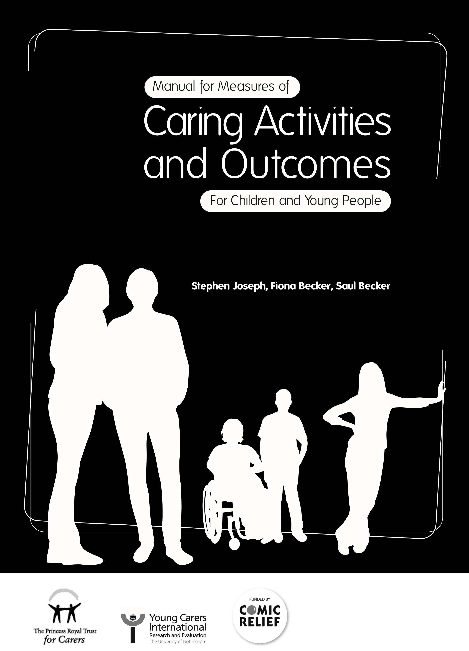

Manual for Measures of
Caring Activities and Outcomes
For Children and Young People
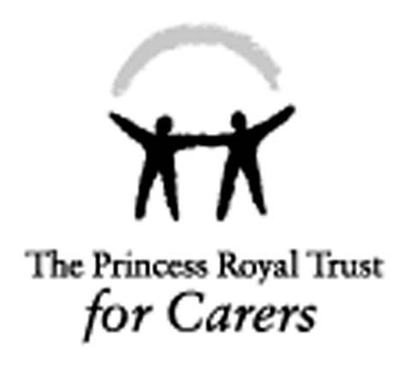
Stephen Joseph, Fiona Becker, Saul Becker
First published in Great Britain in March 2009 by The Princess Royal Trust for Carers, Unit 14, Bourne Court,
Southend Road, Woodford Green, Essex, IG8 8HD, in association with Young Carers International Research
and Evaluation, School of Sociology and Social Policy, The University of Nottingham, University Park,
Nottingham NG7 2RD.
© Stephen Joseph, Fiona Becker and Saul Becker
A catalogue record for this Manual is available from the British Library.
ISBN 13 9780853582533
Stephen Joseph is Professor of Psychology, Health and Social Care and Director, Centre for Trauma,
Resilience and Growth, The University of Nottingham.
Fiona Becker is a Senior Research Fellow in the School of Sociology and Social Policy, The University
of Nottingham and a Senior Consultant, NSPCC.
Saul Becker is Professor of Social Policy and Social Care and Head of the School of Sociology and Social
Policy, The University of Nottingham.
The right of Stephen Joseph, Fiona Becker and Saul Becker to be identified as authors of this work has been asserted by them in accordance with the 1988 Copyright, Designs and Patents Act.
All rights reserved: no part of this publication may be reproduced, stored in a retrieval system, or transmitted in any form or by any means, electronic, mechanical, photocopying, recording, or otherwise as part of research projects or surveys without specific written permission from the authors. The instruments in the Manual may be photocopied and used by practitioners within their own organisation for individual assessment and clinical use. Photocopies may not be made for distribution to other organisations. All other copyright restrictions remain in force.
The statements and opinions contained within this publication are solely those of the authors and not of The Princess Royal Trust for Carers.
Funding
The development of the outcome instruments and publication of the Manual was funded by Comic Relief
in association with The Princess Royal Trust for Carers.
Competing interests
No financial or competing interests have been declared by the authors.
Download
This Manual can be downloaded for free from: www.carers.org and www.saulbecker.co.uk
Citation
This Manual should be cited as: Joseph, S., Becker, F. and Becker, S. (2009)
ManualforMeasuresofCaring
ActivitiesandOutcomesforChildrenandYoungPeople.
London: The Princess Royal Trust for Carers.
Design and production by Touch Design: www.touchdesign.co.uk

Acknowledgements
The authors acknowledge with gratitude the help of the young carers projects that piloted the outcome instruments. Thanks to Steve Regel and Roda Madziva at The University of Nottingham. The advice and guidance from Alex Fox at The Princess Royal Trust for Carers was also greatly appreciated.
2.
Contents
page
1.
Context for the development of the measures
1.1
Introduction
01
1.2
Recognising the needs of young carers
01
1.3
Growth in services for young carers
02
1.4
Need for robust measures
02
1.5
A note for users
03
Measures of caring activity and caring outcomes
Introduction to the measures
2.1
04
2.2
Development of the measures
05
2.3 Multidimensional Assessment of Caring Activities (MACA-YC18) 06
2.4 Positive and Negative Outcomes of Caring (PANOC-YC20) 10
Introduction
3.
Additional resources
3.1
13
3.2
13
Multidimensional Assessment of Caring Activities (MACA-YC42)
3.3
What I Like and Dislike About Caring
16
3.4
Post Intervention Self-Assessment (PISA-CR2)
19
4.
References
23
i

1. Context for the development of the measures

1.1 Introduction
This Manual is intended to provide researchers and practitioners in the field of caring with relevant and accessible instruments for the assessment of caring activities and caring outcomes in children and young people. The instruments can be used on a one-off basis for the purpose of assessment, or pre- and post-intervention to measure change and the impact of support. If used pre- and post-intervention, then practitioners working with young carers will be able to inform their funders and other partners about whether or not their work has made a measurable difference. The instruments can measure the extent and nature of caring and its impact on the emotional and social well-being of a young person.

1.2 Recognising the needs of young carers
Many children and young people are involved in caring for parents, siblings, or other relatives who have an illness, disability, mental health condition or other need for care or supervision (Aldridge and Becker, 2003; Becker, 2008; Becker and Becker, 2008a and 2008b; Dearden and Becker, 2000, 2004). These ‘young carers’ are defined as “children and young persons under 18 who provide or intend to provide care, assistance or support to another family member. They carry out, often on a regular basis, significant or substantial caring tasks and assume a level of responsibility that would usually be associated with an adult. The person receiving care is often a parent but can be a sibling, grandparent or other relative who is disabled, has a chronic illness, mental health problem or other condition connected with a need for care, support or supervision” (Becker, 2000, p 378).
There is growing recognition of young carers amongst governments in the UK and overseas as well as policy makers and practitioners working in health, social care and education (Becker, 2007). These different professional domains have recognised that children with caring responsibilities are also their concern whether they be in the classroom, attending their GP or living in a family receiving health and social care interventions. Two central government strategies (Department of Health, 1999; HM Government, 2008) have also highlighted the needs of young carers and what should be done to support them.
01
1. Context for the development of the measures

1.3 Growth in services for young carers
From just a handful of dedicated young carers projects in the early 1990s there are now over 350 projects/services across the UK in contact with around 30,000 young carers (Becker, 2008). This growth in awareness and identification of young carers and in the number of specialist young carers services and projects was triggered and has been maintained by three key factors: first, a growing research literature on young carers and their families; second, the work of charitable organisations that helped to promote public, political and professional awareness, and finally, changes in legislation¹, guidance and policy initiatives (Department of Health, 1999; HM Government, 2008) which have placed greater emphasis on the need for services to assess and support young carers in order to improve their welfare, health, education and general well-being.
Census data in 2001 (Office for National Statistics, 2003) revealed that there were 175,000 young carers (aged 0-18) in the UK, which is 2.1% of all children. Although this figure was higher than expected it is likely to be an under representation since many families will not identify that they have a young carer in their household, rather caring is seen as a ‘normal’ or routine part of their everyday experiences and relationships; or families might not wish to disclose that they have a child caring, especially where there is parental mental illness, substance misuse or other stigmatising conditions such as HIV and AIDS (Aldridge and Becker, 2003; Evans and Becker, 2009).

1.4 Need for robust measures
There has been limited research into the outcomes produced by support services for young carers. Given the significant investment of governmental and charitable resources, and health and social care services for young carers, it is critical that service providers, including the 350 young carers projects in the UK, have robust measures which can be used in this context.
Indeed funding organisations are increasingly demanding robust evidence on outcomes. The government’s national carers strategy (HM Government, 2008) recognised that “a detailed evaluation of the different approaches and their impact on young carers and their outcomes is lacking” (HM Government, 2008, p 131) and it goes on to make a commitment to address this deficit. Additionally, the Every Child Matters programme (HM Government, 2004) in England requires a focus on outcomes for all children.
1 The Carers (Recognition and Services) Act 1995 gives carers of any age the right to an assessment of their ‘ability to provide and to continue to provide care’; The Carers and Disabled Children Act 2000 gives family carers over the age of 16 a right to request an assessment of their own needs and to receive services and support, even if the cared for person does not wish to have an assessment; The Carers (Equal Opportunities) Act 2004 requires local authorities to inform carers of their rights to an assessment in certain circumstances and to consider whether the carer works, undertakes education or training, leisure activities or wishes to do any of these things (see Frank and McLarnon, 2008, for a fuller description of the legal entitlements of young carers).
02
1. Context for the development of the measures
Furthermore, while many countries in the world are now recognising and responding to the needs of young carers few have developed systematic responses including a network of dedicated support projects as in the UK. Research has shown (Becker, 2007) that the experiences and needs of young carers in developed countries such as the UK, Australia and the USA are very similar. The instruments in this Manual will consequently be useable in these countries. Professionals working with young carers outside of specialist young carers projects could also utilise the instruments as they would generate useful information both for assessment and evaluation purposes.
Some young carers services have sought to use generic outcome measures or measures that have been developed for other groups of young people. However, the results generated by the use of non-specific measures may not be reliable when applied to work with young carers. The instruments in this Manual have been developed and tested with young carers so can be used with greater confidence.

1.5 A note for users
The two instruments (MACA-YC18 and PANOC-YC20) in this Manual are intended to be used by professionals in the fields of health and social care (e.g., psychologists, psychiatrists, social workers, nurses, youth workers, young carers workers) as well as those researching informal caring, and caring organisations themselves. As such we expect users to adhere to their organisational child protection and confidentiality policies, their own professional Code of Ethics and to ensure that they are working within their competence. Practitioners should discuss planned use of the instruments with young people, managers and other relevant stakeholders. It should be made clear to young people and their families what will happen to their personal information and how services might respond if answers to the questionnaires raise concerns.
We have endeavoured to compile this Manual so that it is easy to follow and the instructions for use are clear. A fuller explanation and details of the development of the two instruments are available in Joseph, Becker, Becker and Regel (2009).
03

2. Measures of Caring Activity and Caring Outcomes

2.1 Introduction to the measures
The Manual introduces two instruments for the assessment of caring:
The Multidimensional Assessment of Caring Activities (MACA-YC18) is a questionnaire
(an 18-item self-report measure) that can be used to provide an index of the total amount of caring activity undertaken by the young person, as well as six subscale scores for domestic tasks, household management, personal care, emotional care, sibling care, and financial/practical care. The MACA-YC18 can be used before, during and after receiving support in order to identify any changes that have occurred. Go to pages 6-9 for further details.
We also include the MACA-YC42 which is a 42-item checklist of caring activities. It can be used to obtain a detailed picture of the caring activities undertaken by an individual (see Additional Resources section of the Manual for the MACA-YC42). This may be of particular use to practitioners conducting assessments of young carers. Go to pages 13-15 for further details.
The Positive and Negative Outcomes of Caring (PANOC-YC20) is a questionnaire
(20-item self-report measure) that can be used to provide an index of positive and negative outcomes of caring. The PANOC-YC20 can be used before, during and after receiving support in order to identify any changes that have occurred. Go to pages 10-12 for further details.
Both measures are useful in research into caring and its effects, to practitioners in health and social care, youth work, psychology, and social work, and also to young carers organisations interested in evaluating their intervention strategies. The measures provide the resources with which to evaluate whether interventions are associated with changes in levels of caring activity, as well as understanding the psychological effects of caring. The PANOC-YC20 is particularly useful with its focus on negative and positive outcomes of caring and whether support has resulted in a reduction of negative outcomes and an increase in positive ones.
Research has shown that although caring can have many negative effects, like other stressful situations it can also lead to the development of resilience and considerable personal benefits such as increased self-knowledge and maturity (Joseph, Knibbs and Hobbs, 2007; Evans and Becker, 2009). While we recognise this may sometimes be the case and we argue that it is appropriate to assess both negative and positive outcomes of caring, we do not suggest that recognising the positive aspects of caring is justification for leaving young carers unsupported.
04
2. Measures of Caring Activity and Caring Outcomes

2.2 Development of the measures
In the original study, Joseph, Becker, Becker and Regel (2009) reported data from 410 young carers ranging in age from 7 to 22 years of age who were recruited via The Princess Royal Trust for Carers database of UK projects and asked to complete two questionnaires to assess caring activities and caring outcomes, respectively. Following statistical analysis we reduced the length of the two questionnaires and piloted them with another 124 young carers.
The statistical procedure allowed us to select a small set of items which are representative of a particular domain of activity. For example, although we might only ask whether the young person washes dishes, if they say yes to this our statistical analysis indicates that it can be safely assumed that they are likely to do other related activities such as washing clothes. For this reason, we are able to pick only a small number of items to measure various domains of activity, so the overall scores reflect much more than simply what questions are asked.
Thus, 18 items were chosen to compose the Multidimensional Assessment of Caring Activities (MACA-YC18) and 20-items were chosen to compose the Positive and Negative Outcomes of Caring Scales (PANOC-YC20).

05
The MACA-YC18 was designed as a very short, easy to use, psychometric instrument able to provide an index of the extent of caring activities that the young person is currently engaged in (Joseph, Becker, Becker and Regel, 2009). The MACA-YC18 is recommended for:
2
. Measures of Caring Activity and Caring Outcomes
2.3
Multidimensional Assessment of Caring Activities (MACA-YC
18)
The Multidimensional Assessment of Caring Activities (MACA-YC18) is a questionnaire to be
completed by young carers (an 18-item self-report measure) that can be used to provide an
index (or score) of the total amount of caring activity undertaken by a child or young person,
as well as six subscale scores for:
domestic tasks,
(1)
(2)
household management,
(3)
personal care,
(4)
emotional care,
(5)
sibling care, and
(6)
financial/practical care.
- Use in surveys of the amount of caring activity undertaken by children and young people.
- To compare different groups of children and young people on the amount of caring activity.
- To use before and after interventions to examine what sort of interventions are helpful in reducing caring burden.
- To examine the association between caring activity and other factors – such as age and gender.
- To use in a one-to-one context by professionals who want to understand the types of caring tasks undertaken, but where time is short.
06
How to use the MACA-YC18
Care has been taken to ensure that the wording is appropriate for most children and young
people so that they will be able to complete the MACA-YC18 by themselves. Although it may
be appropriate sometimes to help with explanations, we recommend that children and young
people are given the opportunity to complete the MACA-YC18 by themselves whenever possible.
When it is necessary to provide explanations this should be carried out by the professional
involved. We do not recommend that the MACA-YC18 be completed in the presence of the
person who is being supported. Young carers’ responses on the MACA-YC18 should always be
treated in confidence and used in line with an appropriate professional Code of Ethics and
within an organisation’s child protection and confidentiality policies.
The MACA-YC18 can be used to provide an overall summary score (index) of caring activity by totalling all 18 items. The lowest the young person can score is 0 and the highest the young person can score is 36. For example, if the young person ticks ‘never’ for each of the 18 items, they would get a total score of 0 but if they ticked ‘a lot of the time’ for each of the items, they would get a score of 36. Of course, most children and young people will score somewhere in between these two extremes. The average score is around 14.
2
. Measures of Caring Activity and Caring Outcomes
Scoring for the MACA-YC18
For the MACA-YC18 each of the items are rated on a 3-point scale, ‘Never’, ‘Some of the time’,
and ‘A lot of the time’.
For scoring purposes:
‘Never’
=
0
‘Some of the time’
=
1
‘A lot of the time’
=
2
Overall Score of Caring Activity
Interpretation of scores on the MACA-YC18
Higher scores indicate greater levels of caring activity. The following categories are useful:
07
0
No caring activity recorded
1-9
Low amount of caring activity
10-13
Moderate amount
14-17
High amount
18
and above
Very high amount of caring activity
Financial and Practical Management – the extent to which the young person helps financially (for example with bills, benefits and banking), and takes practical adult responsibilities (such as working part-time, interpreting) etc.
2
. Measures of Caring Activity and Caring Outcomes
Subscale scores
For more sophisticated research and assessment purposes where an individual profile for the
young person is required, it is also possible to use the MACA-YC18 to identify the pattern of
caring activity in six domains (subscales):
(1)
Domestic Activity
– the extent to which the young person engages in activities such
as cleaning, cooking, washing dishes or clothes etc.
(2)
Household Management
– the extent to which the young person engages in activities
to keep the household running such as shopping, household repairs and lifting heavy
objects etc.
(3)
- Personal Care – the extent to which the young person engages in caring activities such as helping the person dress and undress, wash and use the bathroom, helping with mobility and giving health care (such as administering medicine or changing dressings) etc.
- Emotional Care – the extent to which the young person provides company and emotional support to the person, keeping an eye on them, providing supervision and taking them out.
- Sibling Care – the extent to which the young person is responsible for looking after siblings either alone or with a parent present. This excludes any young person caring for his/her own child.
08
To calculate subscale scores:
Subscales
Add the scores from the following questions:
Domestic Activity
Questions 1,2 and 3
Household Management
Questions 4, 5, and 6
Questions 7, 8, and 9
Financial and Practical Management
Personal Care
Questions 10, 11, and 12
Emotional Care
Questions 13, 14, and 15
Sibling Care
Questions 16, 17, and 18

^{MACA-YC18}
Below are some jobs that young carers do to help. Think about the help you have provided over the last month. Please read each one and put a tick in the box to show how often you have done each of the jobs in the last month. Thank you.
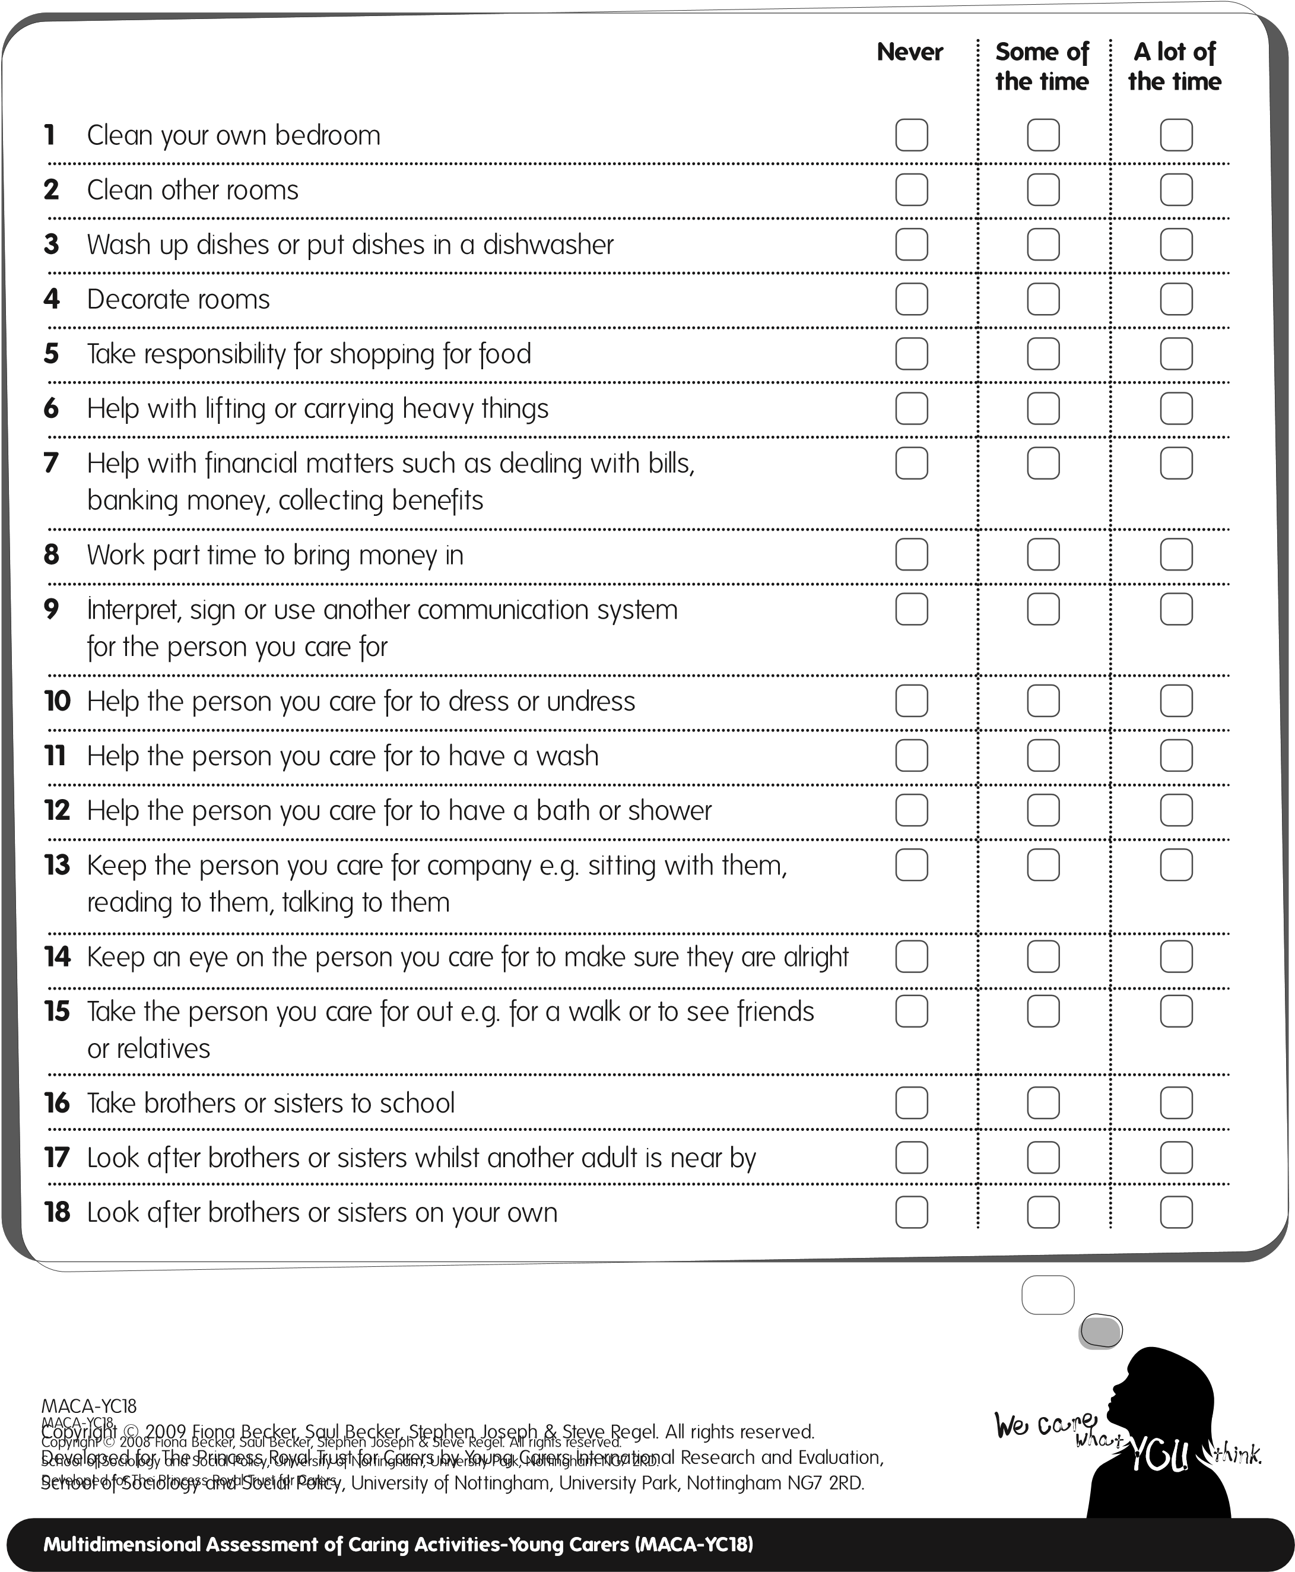
2. Measures of Caring Activity and Caring Outcomes

2.4 Positive and Negative Outcomes of Caring (PANOC-YC20)
The Positive and Negative Outcomes of Caring (PANOC-YC20) is a questionnaire to be completed by young carers (a 20-item self-report measure) that can be used to provide an index (or score) of the subjective cognitive and emotional impact of caring in young people. Research and practice have identified that many young carers are significantly affected by their caring responsibilities both negatively and positively. For this reason, the PANOC-YC20 was designed to provide two scores. One score showing how much caring is experienced negatively and one showing how much caring is experienced positively.
Scoring
The PANOC-YC20 is a 20-item psychometric instrument designed to assess the positive and negative effects of caring activity. Each item is rated on a 3-point scale, ‘Never’, ‘Some of the time’, and ‘A lot of the time’.
For scoring purposes:
‘Never’ = 0
‘Some of the time’ = 1
‘A lot of the time’ = 2
The PANOC-YC20 consists of two 10-item subscales: (1) positive responses, and (2) negative responses. Scores on both the subscales have a potential range of 0 to 20, with higher scores indicating greater positive and negative responses, respectively.
To calculate the positive response score: sum items 1, 2, 3, 4, 7, 8, 15, 18, 19, and 20. To calculate the negative response score: sum items 5, 6, 9, 10, 11, 12, 13, 14, 16, and 17.
10
Interpretation of scores
Statistical analysis indicates that scores of less than 12 on the PANOC-YC20 positive scale
and/or greater than 8 on the PANOC-YC20 negative scale may be indicative of concern
(
see Table 1). For example, this may indicate that the young person is suffering from emotional
distress. In such circumstances practitioners will need to follow their usual working practices
and procedures in terms of exploring the young person’s feelings with them and their family
and responding appropriately, perhaps in partnership with appropriate health or children’s
social care services.
. Measures of Caring Activity and Caring Outcomes
2
Table 1: Interpreting scores on the PANOC-YC20
Interpretation
Scores
Positive
0
No positive outcomes reported – potential for concern
Relatively few positive outcomes, potential for concern
1-12
Relatively high positive outcomes reported
13-20
Negative
No negative outcomes reported
0
Relatively few negative outcomes reported
1-8
9-20
Relatively high negative outcomes reported, potential for concern
Of most concern will be those young carers who score less than 12 on the positive
scale AND greater than 8 on the negative scale.
However, where there are serious
concerns we recommend that the PANOC-YC20 be used as part of a fuller assessment
process by qualified health and social care professionals.

11

^{PANOC-YC20}
Below are some things young carers like you have said about what it feels like to look after someone. Please read each statement and tick the box to show how often this is true for you. There are no right or wrong answers.
We are just interested in what life is like for you because of caring. Thank you.
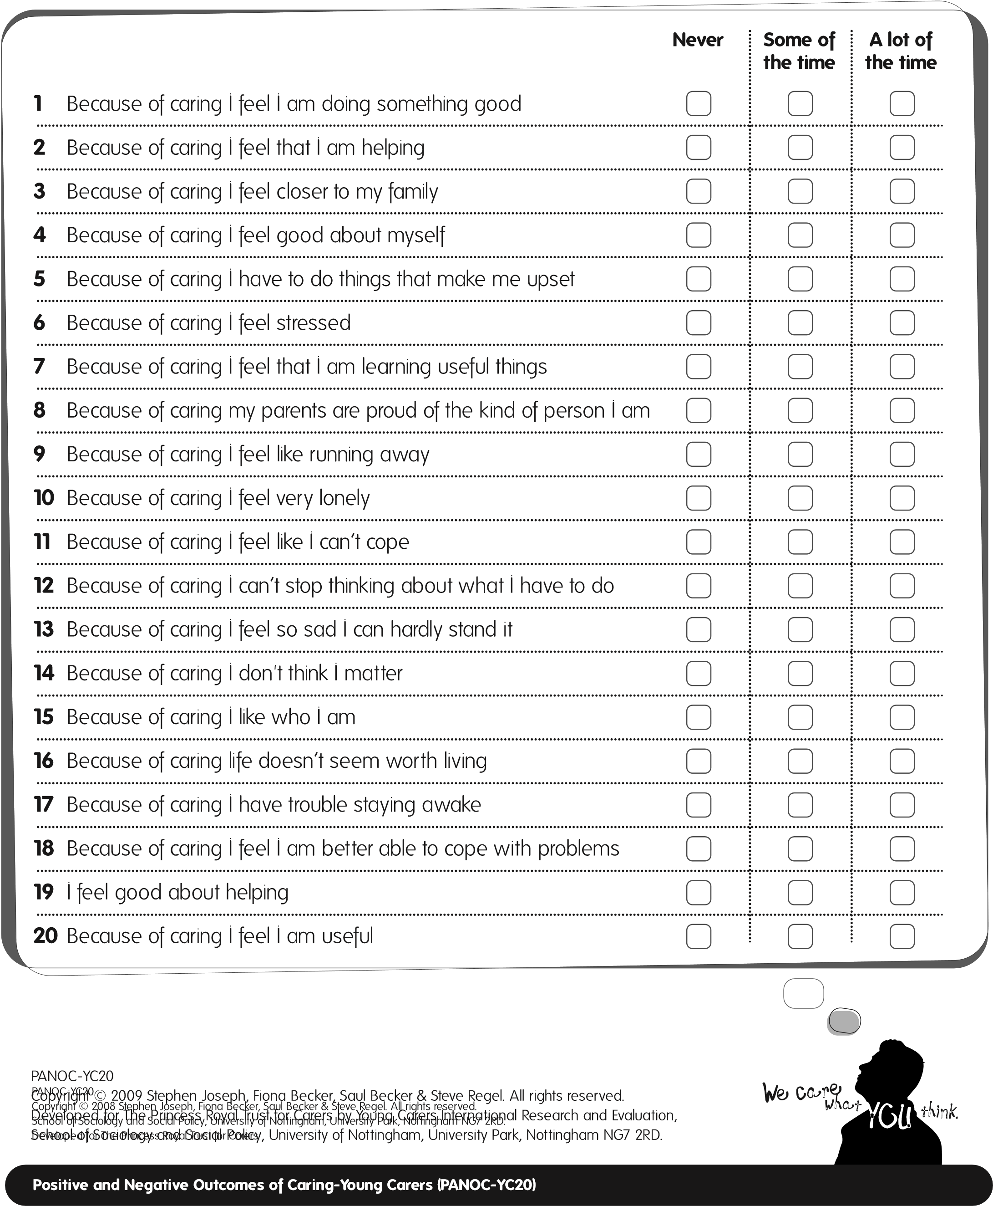
3
. Additional Resources
3.1
Introduction
Additional resources are included in this section as professionals may find these complimentary
to the outcome measurement tools (MACA-YC18 and PANOC-YC20). They are potentially useful
questionnaires that can inform individual assessments of need or evaluation of interventions.
They include some areas not already covered by the MACA-YC18 and PANOC-YC20, for
example, the young carer’s views on the support they have been provided with and their
participation in, amongst other things, education. Three additional resources are included
in this section:
Multidimensional Assessment of Caring Activities-Young Carers (MACA-YC42)
•
•
What I Like and Dislike About Caring
Post-Intervention Self Assessment (PISA-CR2)
•

3.2 Multidimensional Assessment of Caring Activities-Young Carers (MACA-YC42)
While we would recommend the use of the MACA-YC18 in most research and professional contexts because it is shorter and has been carefully refined to produce six subscale scores, there are occasions when professionals may wish to use the MACA-YC42. The MACA-YC42 might be useful in one-to-one contexts when professionals want to explore with young carers the nature and extent of their caring tasks.
13
Scoring
For the MACA-YC42, each of the items are rated on a 3-point scale, ‘Never’, ‘Some of the time’,
and ‘A lot of the time’.
For scoring purposes:
‘Never’
=
0
‘Some of the time’
=
1
‘A lot of the time’
=
2
Overall Index of Caring Activity
The MACA-YC42 can be used to provide an overall summary index of caring
activity by totalling all 42 items. The lowest the young person can score is
0
and the highest the young person can score is 84. For example, if the
young person ticks ‘never’ for each of the 42 items, they would get a total
score of 0 but if they ticked ‘a lot of the time’ for each of the items, they
would get a score of 84. Of course, most people will score somewhere
in between these two extremes. Higher scores indicate greater levels
of caring activity.
MACA-YC42
Below are some jobs that young carers do to help. Think about the help you have provided over the last month. Please read each one and put a tick in the box to show how often you have done each of the jobs in the last month. Thank you.
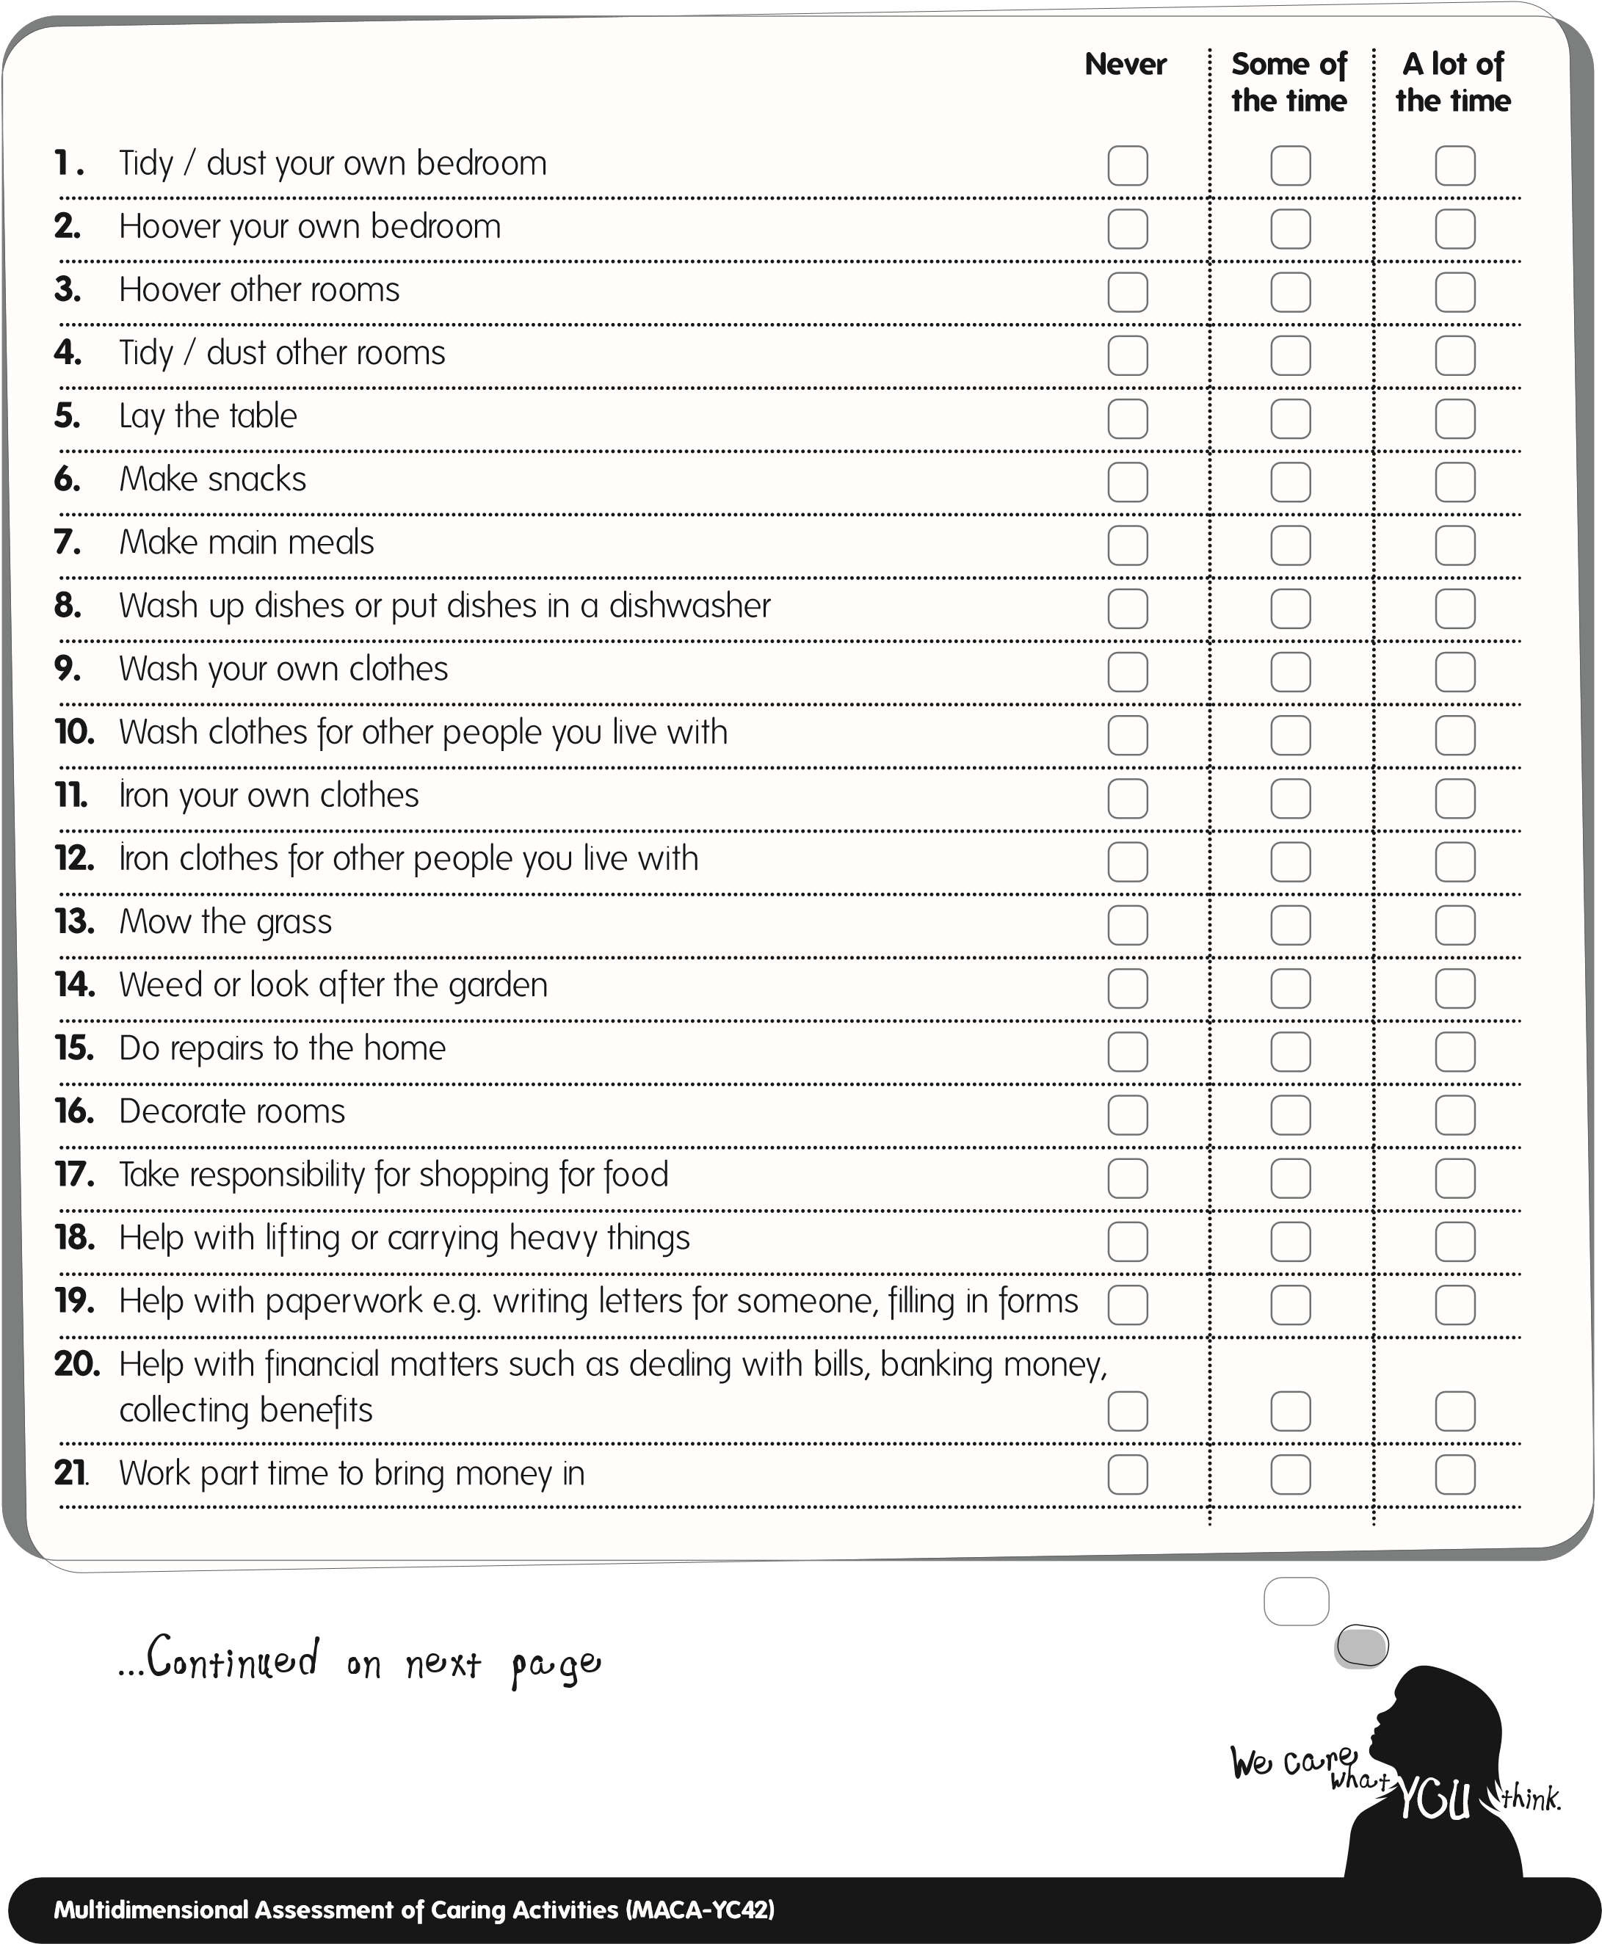
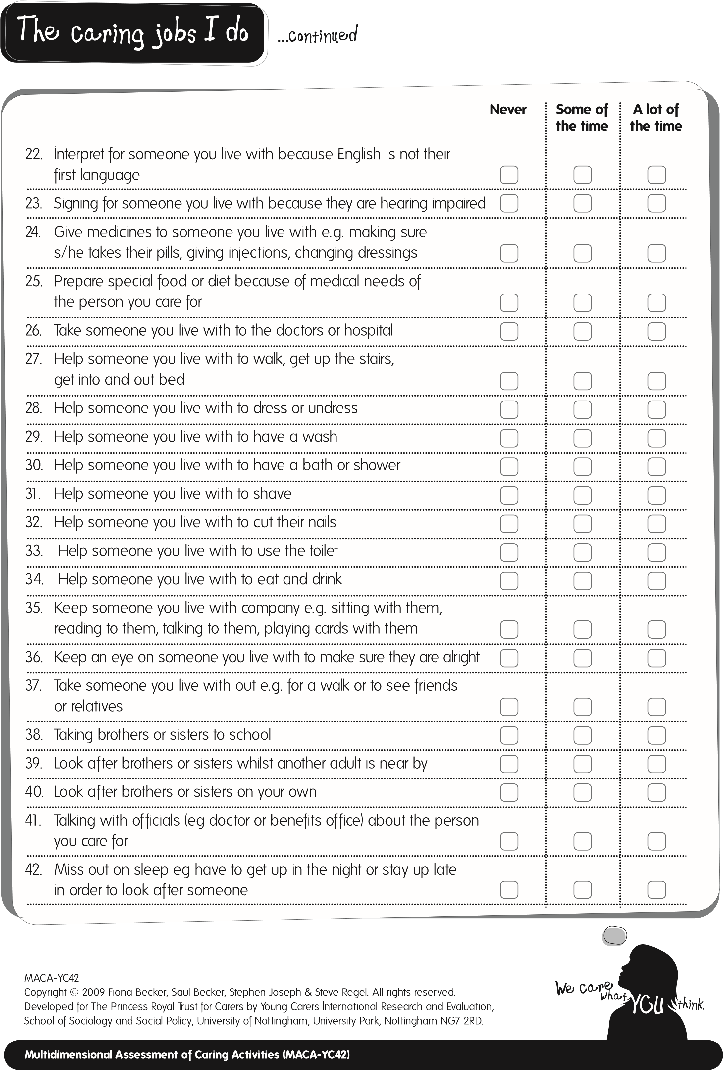
3. Additional Resources

3.3 What I Like and Dislike About Caring
The purpose of this short questionnaire is to enable professionals to gain an understanding of the nature and extent of caring undertaken and the young carer’s feelings about the caring tasks they do. The questions are designed to elicit children and young people’s positive perceptions as well as what they dislike doing or find upsetting. This information can inform assessments and intervention plans for the young carer and their family. Information about what children and young people dislike and find upsetting (in terms of their caring roles) can also be used to develop a better understanding of what might be ‘inappropriate’ caring tasks with regards to individual young carers. Protection from inappropriate caring tasks is identified as a key aim of the government’s strategy for interventions with young carers and their families (HM Government, 2008).
This questionnaire is different from the MACA-YC18 in that it allows young people to describe, in their own words, what they like, dislike and find upsetting about caring. There is no ‘scoring’ associated with these responses. This questionnaire can be used with young carers before, during and after receiving support in order to see if there have been any change in perceptions.

16

We want to ask you some questions about the hours you spend caring and what caring tasks you like and dislike the most. There are no right or wrong answers to any of the questions, we are just keen to hear what you think. Thank you.

Thinking about all the jobs you do in the home,
including keeping an eye on people, please tell
us how many hours of caring you do on a
typical
day
in the week (Monday to Friday)?
hours per weekday
What I like and dislike about caring
How many hours of caring do you do on a
typical
day
at the weekend (Saturday or Sunday)?
hours per day at weekend
At what age did you first start to do caring jobs?
age
Which one of your caring jobs do you like the most? Please tell us a little bit about it.
Please say why you like this caring job.

What I like and dislike about caring
Which one of your caring jobs do you dislike the most? Please tell us a little bit about it.
Please say why you dislike this caring job.

Which one of your caring jobs upsets you the most? Please tell us a little bit about it.
Please say why this caring job upsets you .

In the last 2 weeks of term time, how many days have you
missed at school, college or university because of caring?
days missed
In the last 2 weeks of term time, how many days were you
late for school, college or university because of caring?
days late
What I Like a
nd Dislike about Caring
Copyright © 2008 Saul Becker, Fiona Becker & Stephen Joseph. All rights reserved.
School of Sociology and Social Policy, University of Nottingham, University Park, Nottingham NG7 2RD.
Developed for The Princess Royal Trust for Carers.

What I like and dislike about caring
ol of Sociology and Social Policy, University of Nottingham, University Park, Nottingham NG7 2RD.
Developed for The Princess Royal Trust for Carers.
What I Like and Dislike About Caring
Copyright © 2009 Saul Becker, Fiona Becker, Stephen Joseph. All rights reserved.
Developed for The Princess Royal Trust for Carers by Young Carers International Research and Evaluation,
School of Sociology and Social Policy, University of Nottingham, University Park, Nottingham NG7 2RD.
3. Additional Resources

3.4 Post Intervention Self-Assessment (PISA-CR2)
This questionnaire ‘Me and My Young Carers Project’ has been designed to elicit young carers’ views of the interventions they have received and the impact these have made in certain areas of their lives. It asks young carers to explain what type of support they have received, their views about the support and any resultant changes in terms of their experiences of school or college and the amount of caring activity undertaken. Some of the information gained can be usefully compared with the information collected from the ‘What I Like and Dislike About Caring’ questionnaire completed at the pre-intervention stage. The PISA-CR2 has been designed specifically to examine areas of importance to a specific grants programme and can be amended to collect other types of information or to self-assess other outcomes.

19

Here are some ways that the project might have helped you.
Please read the list and tick the box to show whether this is true for you.
There are no right or wrong answers. We just want to know what you think.
Yes
No
1
I enjoyed most of the activities
2
The project helped me make new friends
3
The project taught me useful things
4
The project was worth going to
5
The project made me feel good about myself
6
The project made me feel good about my family
7
The project helped the person I care for
What kind of help and support have you been getting from your Young Carers Project?
Please tell us a little bit about it.
PISA-CR2

Here are some things that might have changed for you since going to the project.
Please read the list and tick the box to show whether this is true for you.
There are no right or wrong answers. We just want to know what you think.
Yes
Because of the project…
No
1
I now attend school or college more often
2
I now enjoy school or college more
3
I now do better at school or college
4
People pick on me less at school or college
5
I now do less caring
6
I now do less of the caring jobs that I dislike
7
I now do less of the caring jobs that upset me
8
I now do less of the caring jobs that worry me the most
9
People are more understanding of the caring jobs that I do
Please tell us one thing, if anything, which has changed for you because of attending
this project.
Please tell us one thing, if anything, which has changed
about your caring jobs because of attending this project.

Thinking about all the jobs you do in the home, including keeping an eye on people, please tell us how many hours of caring you now do on a
typicaldayin the week (Monday to Friday). hours per weekday

Please tell us one thing, if anything, that you didn’t like about attending the project.

Is there anything else you would like to tell us?
How many hours of caring do you now
do on a
typicalday
at the weekend
(
Saturday or Sunday)?
hours per day at weekend
PISA-CR2
Copyright © 2009 Saul Becker, Fiona Becker, Stephen Joseph. All rights reserved._{PISA-CR2}

Developed for The Princess Royal Trust for Carers by Young Carers International Research and Evaluation,Copyright © 2008 Saul Becker, Fiona Becker & Stephen Joseph. All rights reserved. School of Sociology and Social Policy, University of Nottingham, University Park, Nottingham NG7 2RD.School of Sociology and Social Policy, University of Nottingham, University Park, Nottingham NG7 2RD.
Developed for The Princess Royal Trust for Carers

Becker, S. (2008) ‘Informal family carers’, in K. Wilson, G. Ruch, M. Lymbery and A. Cooper (eds) SocialWork: AnIntroductiontoComtemporaryPractice:Pearson Education, pp 431-460.
4
. References
Aldridge, J. and Becker, S. (1993)
ChildrenWhoCare:InsidetheWorldofYoungCarers.
Loughborough
University: Young Carers Research Group.
Aldridge, J. and Becker, S. (2003)
ChildrenCaringforParentswithMentalIllness.
Bristol: The Policy Press.
Becker, S. (2000) ‘Young carers’, in M. Davies, (ed)
TheBlackwellEncyclopaediaofSocialWork.
Oxford:
Blackwells, p.378.
Becker, S. (2007) ‘Global perspectives on children’s unpaid caregiving in the family: Research and policy
on “young carers” in the UK, Australia, the USA and Sub-Saharan Africa’.
GlobalSocialPolicy,
Vol. 7, No. 1,
pp. 23-50.
Becker, S. and Becker, F. (2008a) ServiceNeedandDeliveryFollowingtheOnsetofCaringAmongstChildren andYoungAdults:EvidenceBasedReview.Cheltenham: Commission for Rural Communities. [Available on 8/1/09 at http://www.ruralcommunities.gov.uk/files/CRC%20web36%20YCIRE.pdf]
Becker, F. and Becker, S. (2008b) YoungAdultCarersintheUK:Experiences,NeedsandServicesforCarers aged16-24.London: The Princess Royal Trust for Carers.
Dearden, C. and Becker, S. (2000) GrowingupCaring:VulnerabilityandTransitiontoAdulthood-YoungCarers’ Experiences.Leicester: Youth Work Press for the Joseph Rowntree Foundation.
Dearden, C. and Becker, S. (2004) YoungCarersintheUK:The2004Report.London: Carers UK.
Department of Health (1999) CaringAboutCarers:ANationalStrategyforCarers.London: Department of Health.
Evans, R. and Becker, S. (2009) ChildrenCaringforParentswithHIVandAIDS:GlobalIssuesandPolicy Responses.Bristol: The Policy Press.
23
The Children’s Society.
HM Government (2004)
EveryChildMatters:ChangeforChildren.
London: Department for Education
and Skills.
HM Government (2008)
CarersattheHeartof21st-CenturyFamiliesandCommunities.
London: Department
of Health.
Joseph, S., Knibbs, J. and Hobbs, J. (2007) ‘Trauma, resilience and growth in children and adolescents’ in A. A.
Hosin (ed.)
ResponsestoTraumatizedChildren.
Houndmills: Palgrave Macmillan, pp.148-161.
Joseph, S., Becker, S., Becker, F., and Regel, S. (2009). ‘Assessment of caring and its effects in young people:
Development of the Multidimensional Assessment of Caring Activities Checklist (MACA-YC18) and the
Positive and Negative Outcomes of Caring Questionnaire (PANOC-YC20) for young carers’.
Child:Care,
HealthandDevelopment.
Office for National Statistics (ONS) (2003)
Census2001data
[
Table SO25]. London: ONS.
Frank, J. and McLarnon, J. (2008) YoungCarers,ParentsandtheirFamilies:KeyPrinciplesofPractice.London:

Manual for Measures of Caring Activities and Outcomes for Children and Young People
Stephen Joseph, Fiona Becker, Saul Becker
This practical ‘hands-on’ Manual is intended to provide researchers and practitioners in the field of caring with relevant and accessible instruments (or tools) for the assessment of caring activities and caring outcomes in children and young people (‘young carers’). The instruments can be used on a one-off basis for the purpose of assessment, or pre- and post-intervention to measure change and the impact of support. The instruments in this Manual have been developed and tested with over 500 young carers so can be used with confidence.
The Multidimensional Assessment of Caring Activities (MACA-YC18) is a questionnaire
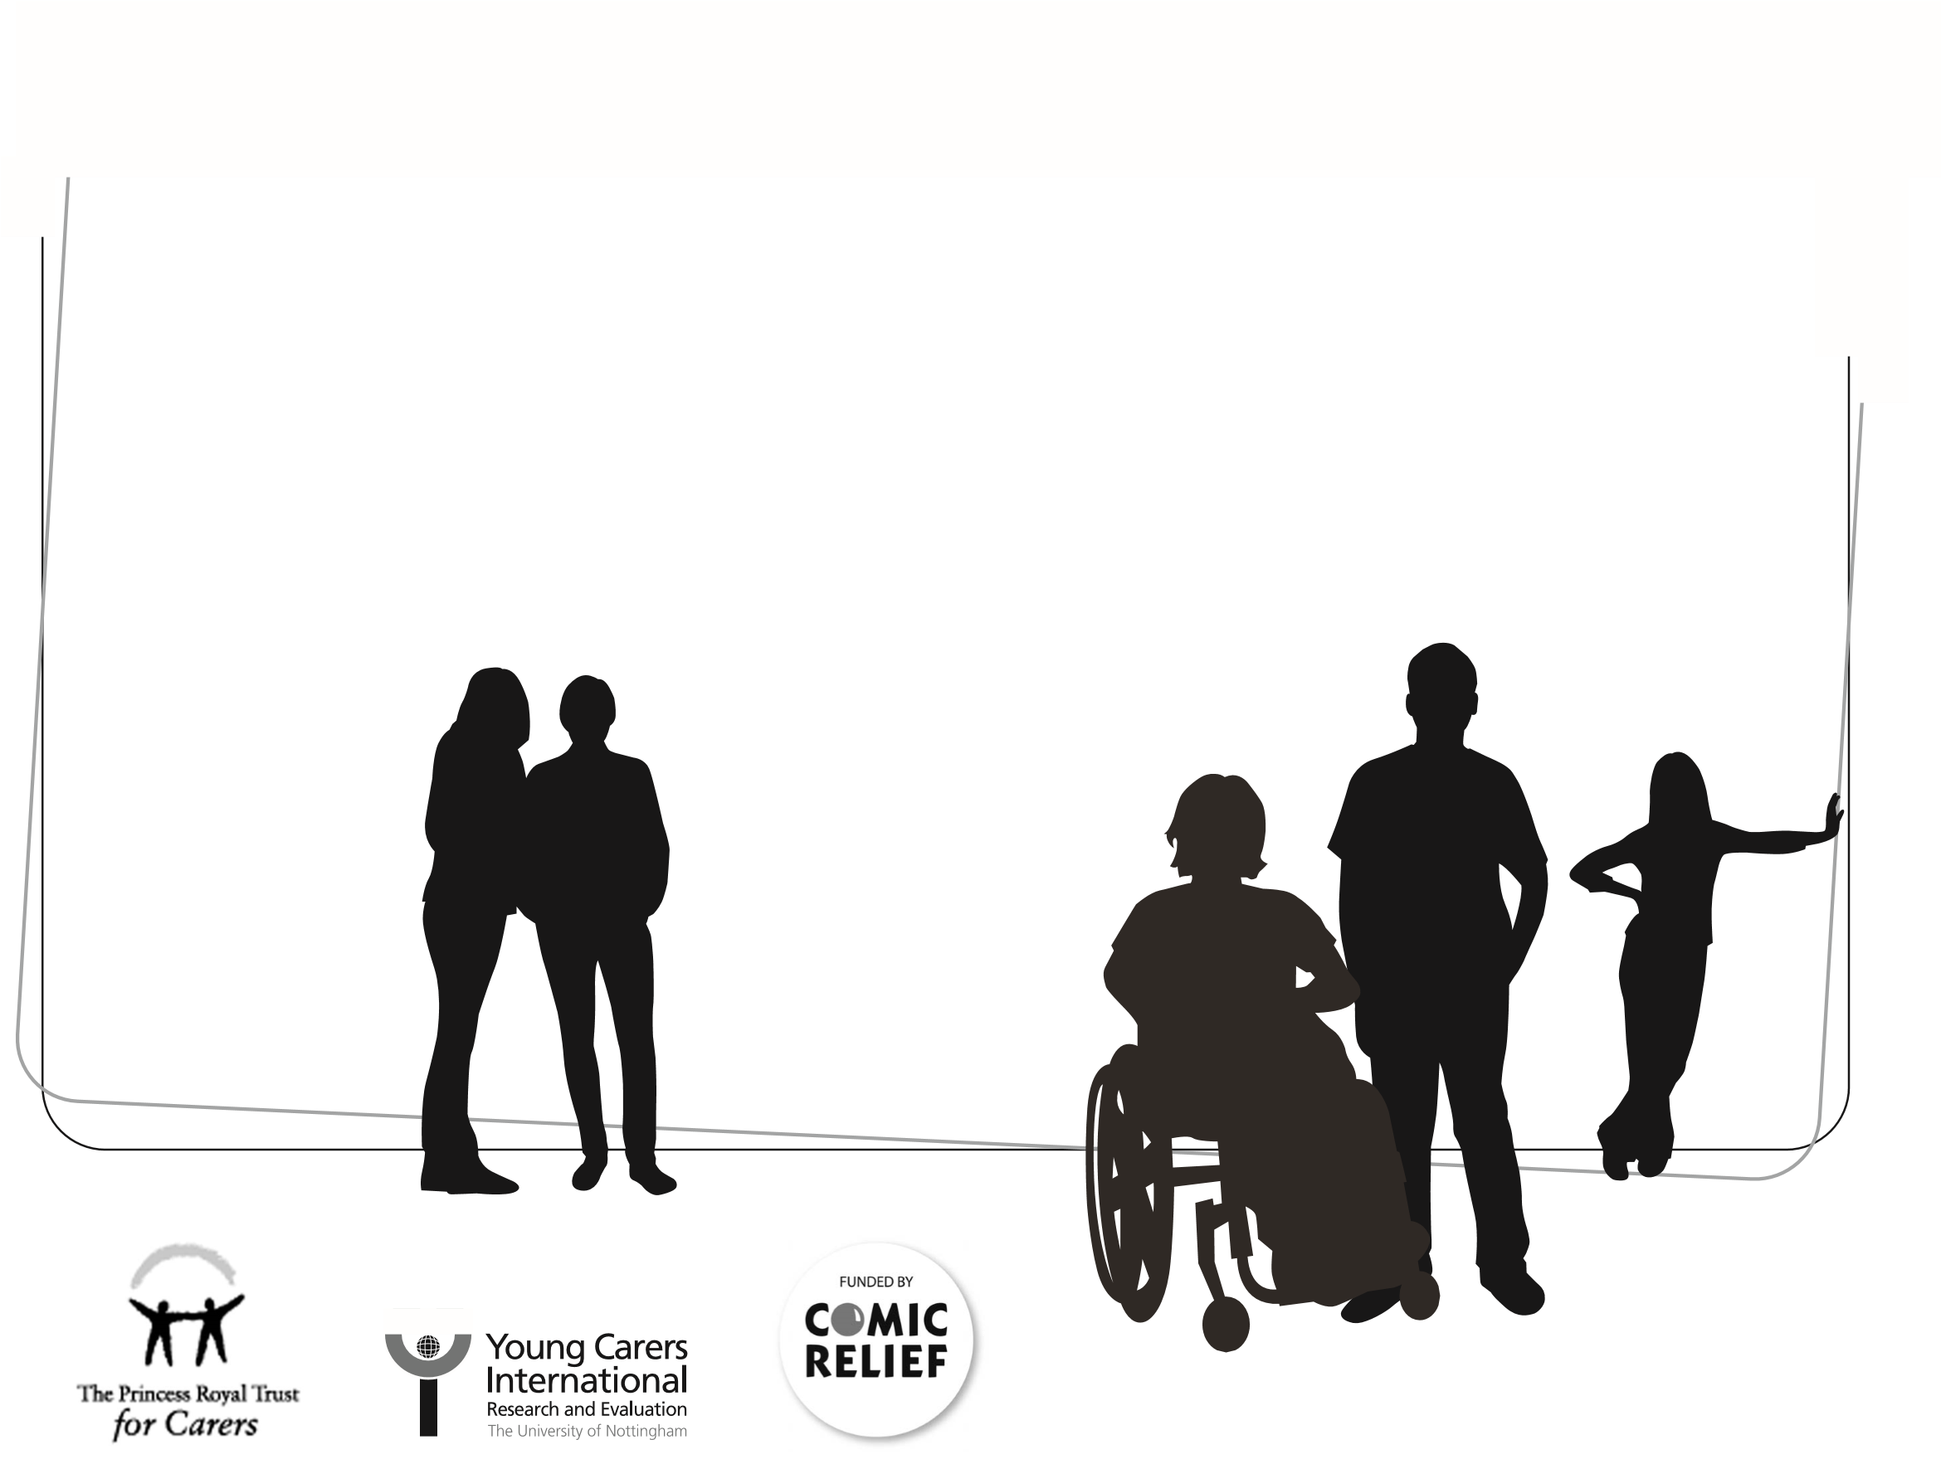
(an 18-item self-report measure) that can be used to provide an index of the total amount of caring activity undertaken by the young person, as well as six subscale scores for domestic tasks, household management, personal care, emotional care, sibling care, and financial/practical care. The Positive and Negative Outcomes of Caring (PANOC-YC20) is a questionnaire (20-item self-report measure) that can be used to provide an index of positive and negative outcomes of caring. Additional resources include an extended version of the MACA-YC18 (the MACA-YC42), and two short questionnaires: ‘What I like and dislike about caring’, and ‘Me and my young carers project’.
The Manual will be of interest to professionals in the fields of health and social care (including young carers workers, social workers, nurses, psychologists, psychiatrists, youth workers) as well as those researching care-giving, and caring organisations themselves.
Published by The Princess Royal Trust for Carers in association with Young Carers International Research and Evaluation, School of Sociology and Social Policy, The University of Nottingham.
ISBN 13 9780853582533

